“ICT entrepreneural skills project; a mean of empowering 50 young Entrepreneurs in Kawempe division” (June-December 2014)
January 2015

Submitted to
HUYSLINC Y2Y facility

Compiled by
Nakakande Irene
Project Manager

Somero Uganda
P. o. Box 21162 Kampala Uganda
Plot No. 834 Kyadondo
Block 203 Kazo
Tel: somerouganda2009@gmail.com
www.somero-uganda.de
1.0: Introduction
Somero Uganda is a grassroots organization which aims at empowering children and young people from the age of 10 to 25 years through education, skills development and Health promotion for self advancement and sustainable community development.

With support from the ILO Y2Y fund run by HUYSLINCI, Somero Uganda successfully implemented a 7 months “ICT entrepreneurial skills project; a mean of empowering 50 young Entrepreneurs in Kawempe division” (June-December 2014). The project was focusing on increasing managerial and Marketing skills of 50 young entrepreneurs dealing in ICT related businesses so as to increase the effectiveness and efficiency of their businesses through trainings on ICT marketing and business management. The target was young entrepreneurs with IT related business within Kawempe division.
The project equipped 50 young entrepreneurs with ICT managerial and marketing skills so as to increase the effectiveness and efficiency of their businesses. The participants were provided knowledge and skills on savings and loan associations, how register their businesses, financial management, use and access to credit and business mentorship.

On completion of the project a follow up activity was conducted to assess the impact. This report therefore provides the findings of this activity.

2.0. Findings of the activity
The findings were categorised according to the relevancy and practicability of the different strategies employed
Entrepreneurial skills were to help participants to better manage and market their businesses hence growth. Atraining on Entrepreneurship using the ILO GET Ahead manual, Classes on ICT book keeping, marketing and research skills were provided throughout the project.
The team found out that the classes on ICT were being employed. Majority of the participants were already using their computers to track their businesses. Market surveys and how to improve on the quality of the products sold was also done on line. It was found out that the participants look at the strategy as cost effective since they do not need to buy books for book keeping and spend on workshops and trainings to gain knowledge and skills for their businesses but rather use internet.

Formalizing businesses was a major component of the project. Weekly entrepreneur mentorship sessions were held to motivate the beneficiaries to formalise their businesses and pay taxes. Support on preparation of documents necessary to register companies and linking them to the registrar of companies was provided.
The team found out that only 40% of the beneficiaries had successfully gone through the registration process and were paying taxes. Though all the beneficiaries had prepared all the necessary documents, the bureaucracy in the process of registration was too much for their patience. Yet others did not continue because of the attached costs. However all of the beneficiaries had paid licence to KCCA for their businesses. They say that being in good terms with the law has helped them to run their businesses without fear.

Access and use of credit from micro financial institutions was discussed in depth. Financial management skills and the formation of saving groups was seen as a strength so the beneficiaries were provided with these skills.
The team found out that the beneficiaries are employing the skills to manage their finances. 4 groups of the 5 formed were still active and members were already getting loans from the groups. This helps them to boast their businesses and support their families. However no one had succeeded in securing funds from the financial institutions because of the bureaucracy.
3.0: Recommendations and Conclusion
We recommend another follow up activity after 6 months. The project was a success as all activities planned were completed. Somero Uganda is very grateful to ILO Youth Entrepreneurship Facility and HUYSLINCI for funding the project and all the other technical support. Appreciation also goes to the Somero Uganda’s stakeholders who supported the project in a number of ways especially facilitating in the different workshops. A vote of thanks also goes to the project beneficiaries, without whom the project would not have been in existence. Let us all continue working together to reduce youth unemployment in Uganda.

4.0. Case studies
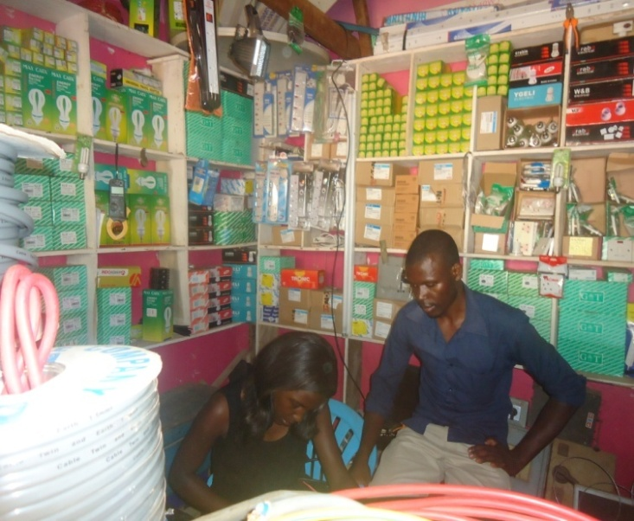
I am by names of Kawooya Sula one of the beneficiaries for the Youth to Youth Fund project. I operate an electronics business. Before the project, the state of my business wasn’t all that pleasing, the stock was 2 million and as I narrate now, the stock is worth 8 million. I had no records for my business but after the trainings on financial management and Somero Uganda’s offer of the ledger books, I now manage well the records of my business, this is enabling me to see how my business is progressing.
The saving culture for my business and as a person wasn’t active but after, I managed to start a saving group, we already opened up an account for our saving group and it is a joint account.
Currently my business has savings of 800,000/= and out of my personal savings I have managed to buy a laptop where I use excel to manage my records (for soft copy records) and from the same savings I have managed to access a passport. I chose this travelling document because in near future I would like to get my stock from outside Uganda. I will need much stock because am also planning to open up another branch.
Still before, my business hadn’t been registered but currently I am operating legally and I have already paid the license for this year which I am so grateful for. I do operate without fear.
Therefore send my token of thanks to the project Somero Uganda won from HUYSLINCI, this has changed my business for the better.
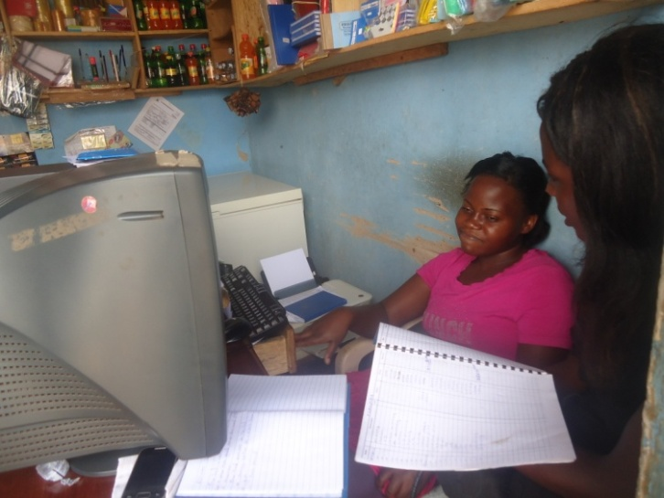

REGINA KYAZIKE are my names, am 22 years old young entrepreneur operating a small stationery with in the slums of Bwaise. Being a young and determined young lady, I had to find means of earning a living and support my family in financial terms. With this, I had to look for money to start up a stationary since I had acquired some computer skills. At First, I was just employed and had saved at least 600,000/= which I used as starting capital. I bought a computer and started printing, typing and photocopying services. This enabled me to earn a living and also take care of my family however my business was not in a good condition since I made huge losses due since I was lacking some business skills.
In June 2014, I heard about a training of young entrepreneurs which was organized by Somero Uganda and it was free of charge, I decided to make use of this opportunity since I had started t a small business but running it unsuccessfully. I had to find ways of acquiring knowledge and skills on how to manage a business. Before the training, I used not to separate the personal and business savings, but currently I have the two different savings and with business I save 3000/= per day as I narrate now I have 300,000/= as business savings planning to buy another computer for my secretarial exercises. This has lessened the huge losses I used to incur.

The only challenge am facing today is a saving group to be part and am not ready to start one now but hopefully I will work on that in the near future. I have also started a culture of book keeping and this has been as a result of the trainings I got.
Thank you so much SOMERO UGANDA and HUYSLINCI the supporting organization.

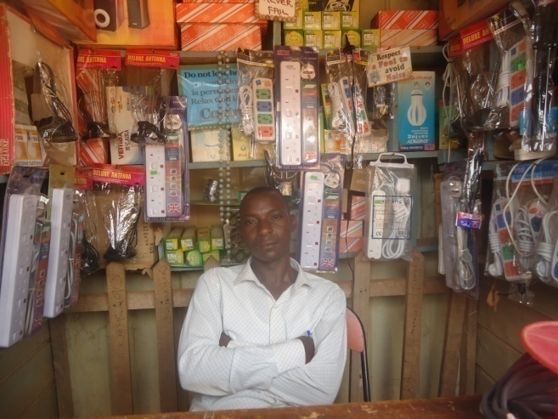
I am by names of Kafeero Andrew, running an electronic business in Kawempe Kilokole zone. Before the training, my business was in a fair state because I had a small stock due to small capital but after being trained the skills of financial management and access to credit, I improved on my saving culture. Currently, my business has savings of 500,000/= and am planning to start a piggery project. At first I didn’t have courage to start another business but now I have the courage to start a second one.
Still, I attained marketing skills where I learnt that good customer care can also market my goods, with this I used to treat my customers any how but now I see them as my bosses. Before the training, I used to report late at my business little did I know that it was so much affecting me and my business too, Currently, since I learnt to be the early bird I catch most warmth and this has contributed to an increase of my stock by 10%.
Before the training, I didn’t know the value of book keeping but after I started and have maintained this exercise and it has worked very well for me since I can now monitor the progress of my business.
The impact of the trainings has also enabled me to think out of the box, before I was contented with the small space I was operating in but now am planning to relocate my business to a bigger space and to always purchase my stock from abroad since am planning to operate on a large scale.
I therefore send a token of thanks to Somero Uganda and the supporting organization HUYSLINCI for the impact they have made on both my life and the business too.

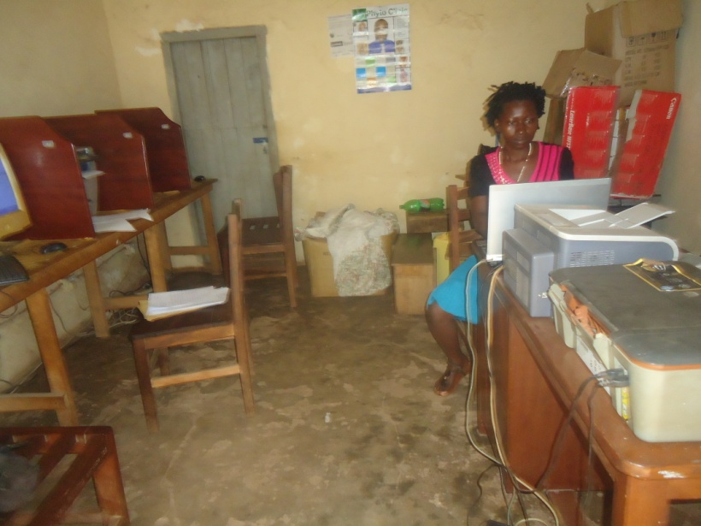
Gorret Nabukenya is my name, I live at kawempe and I operate an internet café and do provide computer training services and any other secretarial services. Before attending the trainings, I already had this business though I used to earn no profits but only incurred losses and I would borrow in order to run the business. Little did I know that savings from the business can sustain it, actually I wouldn’t even get the electricity and internet bills from the business because I was operating in losses.
Early July 2014 I heard about the IT Entrepreneurial project for young entrepreneurs organized by Somero Uganda and the supporting organization HUYSLINCI so I decided to be part of it because I wanted to learn new skills about business management which I exactly got from the entrepreneurship and village saving and loans association trainings. I managed to attain more tips about how to save for business and how to access credit easily. Before, I was attached to some saving group which was only encouraging personal savings but after the training I decided to start saving basically for my business, I managed to train my fellow group members extra skills I had got from the training and one of the skills was not only to save but also to easily access loans from our group. This used not to exist in our group before. As I narrate now, the group is now very strong and members are developing so fast I inclusive. Before the training I did not have any business savings but now I have savings of 480,000/= and with this am setting up a stationery in two weeks time. Still, due to the trainings in financial management and book keeping, before I used not to have proper records, but now I record on a daily basis and this is helping me to see how my business is progressing and am able to plan accordingly.
I conclude by sending a token of thanks to HUYSLINCI which supported Somero Uganda to improve on the business life of young entrepreneurs.
A waiting other trainings!

Compiled by

Nakakande Irene
Project Manager

