Somero Uganda

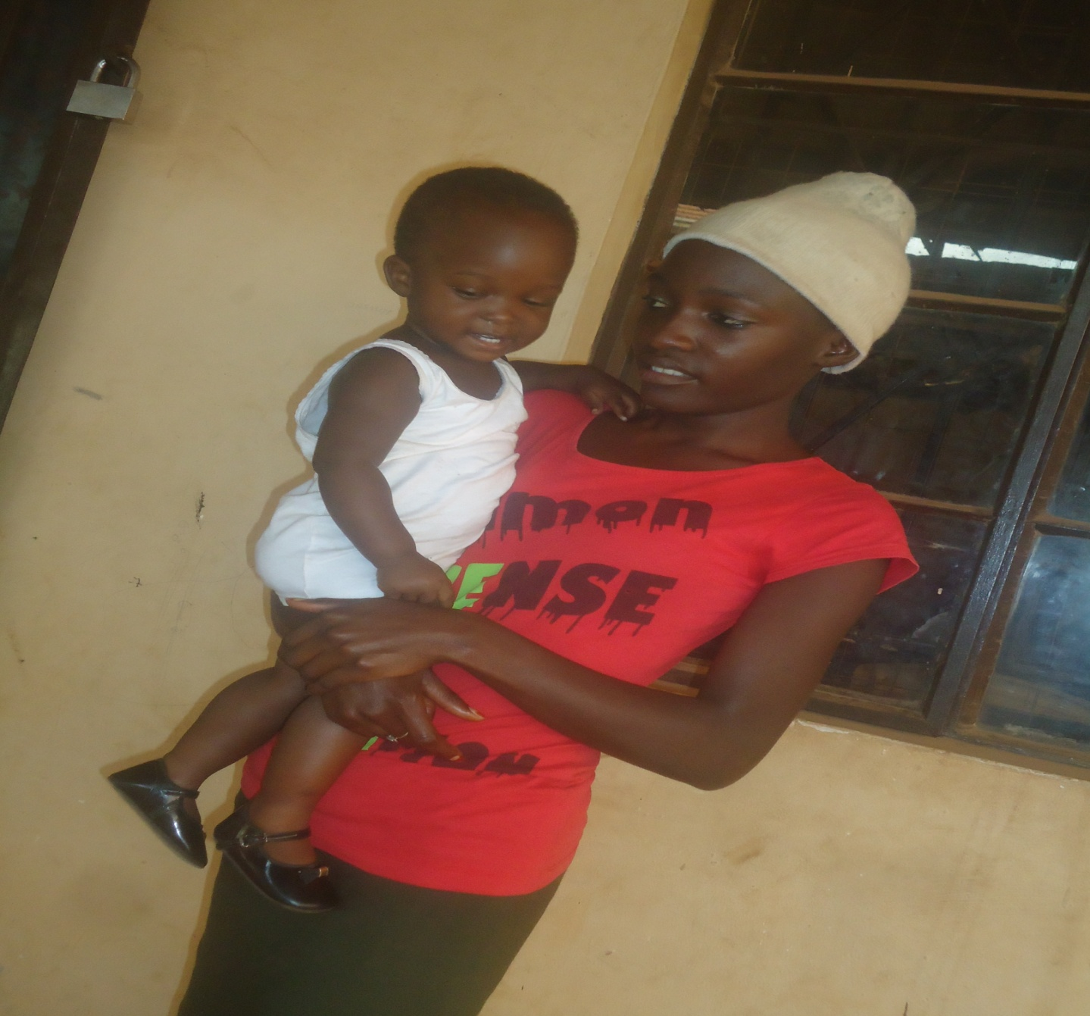

The constitution

THE CONSTITUTION OF SOMERO UGANDA
Preamble
Given the high death rate, ignorance, poverty, and natural disasters in Uganda, young people have been left in a situation of extreme deprivation and vulnerability with children and young women being the most affected and yet these constitute the biggest percentage of the population. Children and young women belong to the most vulnerable groups of society which has been facing a rising rate of school drop outs, leading to exploitation and other social evils.
Majority have been left to survive in the informal service sector, where they are at risk of being exposed to sexual exploitation and violence. Many have ended up forging lives in slums and semi urban areas living as Child laborers, commercial sex workers (CSWs), street workers, drug and alcohol abusers and traffickers among others. Often the young women have endured sexual harassment and many have ended up unintentionally pregnant, despite being still children themselves.
We members here present realizing that the traditional community support systems are inadequate and may not be able to cover the increasing numbers of vulnerable children and young women and
CONVINCED that we could do better to address the plight of children and young women through proper professional Empowerment and education programs and joint effort as an organized group
We the several persons whose names are subscribed here under CONSTITUTE ourselves into Somero Uganda.
NOTE THEREFORE we members of Somero Uganda here assembled on this 3rd day of March in the year of our Lord 2010 do hereby set ourselves the objects detailed in this constitution as our supreme law in our activities as of Somero Uganda.

- ARTICLEI: NAME AND OFFICE
  - The name of the association shall be Somero Uganda, here in after referred to as the organization.
  - The organization shall be a voluntary, non- political and non- profit making organization.
  - The registered office of the organization shall be situated in Kampala District Republic of Uganda
  - The organization shall operate in all parts of the country Uganda.
- ARTICLE II: DEFINITION
  - “children” shall mean any person under the ages of 18year, irrespective of whether they are working, married or refugees
  - “Special children” shall mean children with special needs, irrespective of whether they are working, married or refugees
  - “Vulnerable Young women” shall mean and include females between the age of 18 and 25 years who are deprived of basic needs, education, health, exposed to hard labour and any kind of exploitation, those who are on the streets, brutalized, homeless and poor families and those living in Slums or semi urban areas.
  - “Empowerment” shall mean equipping the children and young women with knowledge and skills to enable them earn a living. Knowledge on financial literacy and entrepreneurship and hands on vocational and soft skills shall be of focus.
  - “Health” shall mean medical health services and healthy behaviors such as not using drugs and alcohol, practicing abstinence, delayed sexual intercourse, no to commercial sex among others.
  - “Community involvement” shall mean engaging children and young women, schools, parents, mentors, local leaders and the government in planning, monitoring, and implementing in any action to improve the social protection and welfare of the organization’s beneficiaries.

  - “Mentorship” shall mean working closely with families, organizations, established business, religious and financial institutions to support the psycho-social and professional growth of the organization’s beneficiaries.

- ARTICLE III: VISION, MISSION AND OBJECTIVES
  - The vision
A Uganda where girls and boys 13-25 years achieve meaningful education and training needed for a self-determined and self-sufficient life to act as agents of social change with full community support.
  - The mission
To offer specific education programs, life skills development and health promotion to Children and young women living in Slums and Semi Urban areas in order to improve their conditions of living and rehabilitation as well as to promote education and the protection of their human rights in their communities.

  - The objectives
    - To increase enrolment and retention of children and young women living in the slums and semi urban areas to at least complete secondary level of education.

    - To increase access to appropriate Vocational and soft skills training among children and young women living in the slums and semi urban areas that they are absorbed in decent work without being exploited.

    - To increase information and access to medical health services and healthy behaviors among children and young women living in the slums and semi urban areas.
    - To mobilize an integrated community area based approach to support and advocate for the promotion of children and women rights.

- ARTICLE IV: THE FUNCTIONS
To achieve the goals and objectives, the association shall carry out the following functions;

  - To provide educational scholarship to vulnerable young people for both formal and informal education.
  - To provide educational logistical support that can enable children, special children and young women to have a safe schooling environment to better their education.
  - To run a centre that facilitates and promotes education and employment opportunities, good health and information sharing.
  - To conduct visits, counseling sessions, life skills building and treatment services to in and out of school children and young women.
  - To prevent, withdraw, rehabilitate and resettle out of school children and young women involved or affected by illicit behaviors.
  - To network on behalf of the children and young women by making referrals to organizations and or individuals who can be of help to them.
  - To build capacity for in school students, the administration, affricated parents and the general communities in the areas geared towards supporting and promoting of the children and young women’s education.
  - To advocate for provision of better and quality education on behalf of the children and young women.
  - To accept and receive money and property by way of subscriptions, donations, banquets and the like with the power to spend money for the objectives of the organization.
  - To purchase, take on lease, hire, receive or otherwise acquire any immovable property and any rights or privileges necessary for the purpose of the organization.
  - To do all things as are incidental or conducive to the proper carrying out of the objectives of the organization.
In furtherance of its goals, objectives and functions, the association Somero Uganda shall remain a non- profit making association and any fees for goods and services where payable shall be used towards the promotion of the vision, objectives and functions of the organization.

- ARTICLE V: MEMBERSHIP
  - Founder membership shall have closed membership for the 9 members whose ideas constituted the formation of Somero Uganda.
  - Associated membership shall according to the discretion of the founder members be open to Persons- including individuals, former beneficiaries, government ministries and officials whose involvement or interests has an impact on children and young women.
  - Membership shall be effective upon payment of a subscription fee determined by the general meeting.
  - Founder members shall be called upon to contribute beyond subscription in cases where need arises.
  - ( I) Voting members: Paid up members shall be eligible for voting carrying one vote each.

(II) Non- voting members: To include government representatives, line ministries, experts
and ex-committee members and other individuals.
  - Responsibilities of members shall include:
- Vote at the general meeting
- Approve budgets and provide funding whenever possible.
- Elect and or approve the Advisory committee
- Appoint auditors
- Propose program direction and pass policies.

- ARTICLE VI: THE ADMINISTRATION
The Administration of this organization shall have in its structure.
- The General Assembly
- The Advisory Committee
- The administrative Unit
- The program unit
- The beneficiaries
- The community
- And any other standing committees as may be determined from time to time.

- The General Assembly
- Shall be the highest decision making body of the organization.
- Shall receive and consider reports from the administrative unit.
- Shall constitute all the paid members of the organization.
- Shall approve the Advisory Committee.
- Shall approve all the objectives and sub- committees
- The Assembly shall be held once every two years and the notice for the meeting shall be distributed at least two (2) weeks in advance.
- One third of the members of the organization shall form quorum.
- The meeting shall discuss and approve the annual budget and audited accounts of the prior year, plans and work programmes. Members present shall carry out elections for the carrying period.
- Questions proposed at the meeting shall be determined by a simple majority (vote or consensus) of the members present and voting. In case of a tie, the person presiding shall call for a second or casting vote.
- The management committee may at any time call for extra- ordinary meetings of the association to discuss any urgent association matters.
- A quorum of members may convene a general meeting to discuss urgent matters through notification and written request to the secretary of the Management Committee within twenty one (21) days thereafter.
- The person presiding shall, with the consent of the meeting convene any meeting from time to time and from place to place transact any business left unfinished.

- The Advisory Committee
- There shall be a committee with people of proven integrity nominated by the administrative Unit and approved by the General Assembly.
- Qualifying members of the general assembly shall also be allowed to sit on the Advisory board.
- The Advisory Committee where necessary shall form sub-committees to which it shall delegate its responsibilities as need arises such as training, finance, planning, monitoring etc.
- A member of the administrative Unit elected by the General Assembly shall sit on the Advisory board as the secretary. The secretary is not entitled to voting at the board.
- The committee shall be a guide and advisor to the Advisory committee.
- Shall receive and consider reports from the administrative unit.
- Shall confer honorary membership to persons that shall qualify as such.

- The Administrative Unit
- The Administrative unit shall include 3 professional officers -2 females and 1 male, the senior programs officer, the National coordinator and the administrative accountant. These shall be appointed by the General Assembly on merit. The qualified organizational members shall be given priority.
- The administrative unit shall be responsible for executing all policies, programs, projects, tasks and duties as proved by the General Assembly and the Advisory Committee in accordance.
- The Administrative Unit shall be the face of the organization.
- Shall appoint the staff and volunteers in the program unit.
- Shall act as custodian and the coordinating body of the organization.
- Shall be the signatories to the organization’s Accounts unless otherwise decided by the general assembly.
- Shall take emergency decisions in consultation with the Advisory board on behalf of the general assembly in extra ordinary circumstances when he/ she can’t in any way consult the general assembly members and report to the members within seven days.
- Shall prepare a general report on all activities of the organization at the end of every quarter.
- A member of the administrative unit shall in event of abscensure delegate his/her office to any of the employees as approved by the Advisory Committee.
- ARTICLE VII: FINANCIAL STRUCTURE
- The Advisory Committee and finance sub- committee shall oversee finances of the organization with the support of the Board of Governors.
- A budget and an audited statement of accounts prepared by the treasurer and the administrative unit shall be presented to the Advisory Committee annually who shall present to the General Assembly.
- Sources of funds will include:
- Membership
- Donor support
- Government grants
- Membership subscription shall be subject to review by the general assembly.
- Once every year, the accounts of the association shall be examined by properly qualified editors.
- AMMENDMENT OF THE CONSTITUTION
The constitution shall be amended in whole or in part after expression of interest of the administrative unit to include it on the agenda.
- DISSOLUTION OF THE ORGANIZATION
The organization may at any time be dissolved by a resolution passed by two thirds of founder members who shall present their resolution at the general meeting of the organization for which at least twenty one (21) clear days notice shall have been sent to all members of the organization. In the event of such dissolution, the assets shall in the first instance be used to discharge any liabilities legally due by the organization and any surplus funds and assets remaining thereafter shall be distributed to any surplus funds and assets remaining thereafter shall be distributed to any organization having similar objectives to the objectives of the Somero Uganda.

Somero Uganda

