SOMERO UGANDA

MENSTRUATION AND MENSTRUAL MANAGEMENT

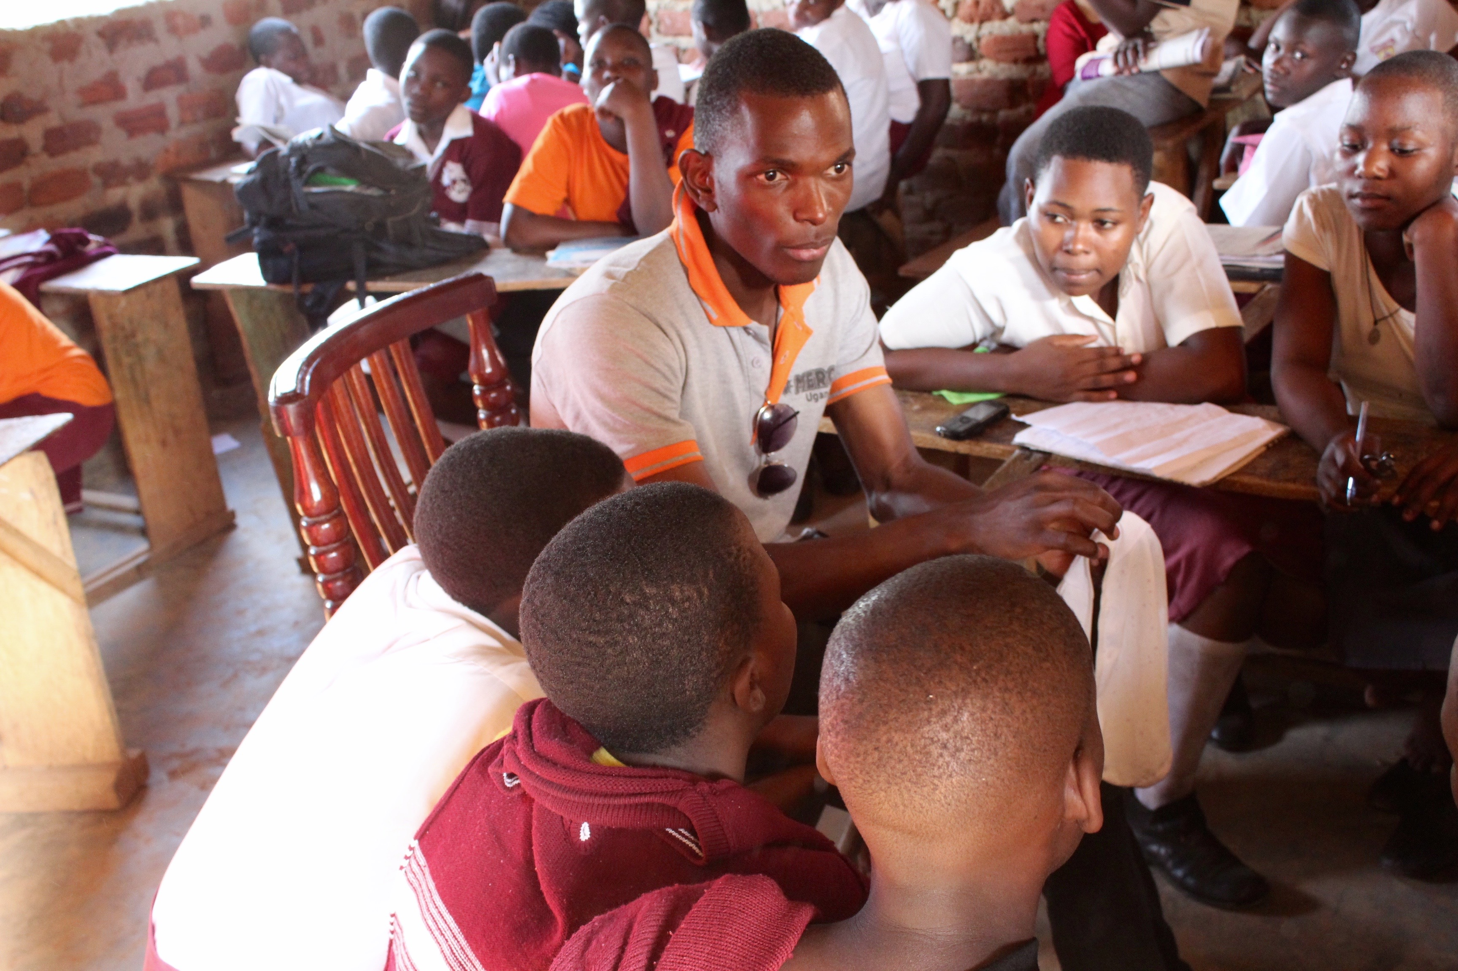

A report on workshops held in schools in Kawempe division, Kampala district

Somero Uganda August 2015

The organization-Somero Uganda

Somero Uganda is a grassroots registered organization founded in 2009 by a group of young people from the slums of Kawempe division Kampala, Uganda. Somero’s Vision is a Uganda where girls and boys 13-25 years achieve meaningful education and training needed for a self-determined and self-sufficient life to act as agents of social change with full community support. The target groups are children and youth with a special focus on young women especially involved commercial sexual activities; affected by drugs, trafficked, early marriage and young mothers.

We run a community centre in Bwaise, Kawempe where a youth corner among others is a major component. The corner provides a safe space for out-of-school youth to meet and share ideas and information on available employment opportunities, and other issues affecting them. The youth also identify community challenges and plan projects to improve such challenges.

In the month of August 2015, Somero youth saw the need to work on a project on menstruation and mistral management. The project was implemented in schools.

Acknowledgement
Somero Uganda wishes to acknowledge the support of Ms. Ronja Thoma from Germany Ms. Kasia Fojucik and Mr. Sebastian Dorsch students from Global Education Network who supported the implementation of this youth project; your efforts were highly recognized. Gratitude also goes to the staff and Volunteers of Somero Uganda especially the team leader Mr. Nsubuga Geofrey for providing a safe youth space and all the youth who worked together on the project. The schools, which participated in the project are also highly appreciated.

Background
“1 out of 10 African school girls skips school or drops out of school entirely due to a lack of menstrual products and poor access to proper sanitation, according to UNICEF. This critical unavailability of sanitary products in developing countries is a major barrier to education for girls of school-going age. The inability to effectively manage menstruation contributes to missing of up to 4-5 school days each month, equating to as much as 20% of the academic year skipped, simply due to menstruation. Eventually many of these girls drop out of school completely, increasing their likelihood of teenage pregnancy, health complications and early marriage, and further limiting their future career and economic opportunities.”(http://afripads.com/what-we-do/the-issue).
In Uganda and Africa in general, it is commonly seen or heard in media and from personal stories that many girls miss classes because of their menstruation. This is mostly because majority of families do not find it as a need to provide their children with sanitary pads, because of poverty. Use of sanitary pads is usually seen as a luxury that can only be afforded by rich families. Therefore, many girls drop out of school because of missing days during their menstruation and so they cannot catch up with their classmates anymore, while other are stigmatized at school by their fellow students, due to poor management of the menstruation.
During Somero’s schools and community sensitization program, menstruation was identified as one of the causes of female dropouts in schools. Also as per the 2014 statistics by Build Africa in Bukedea, 90 % of the interviewed girls reported to be using rags to pad themselves, 24.3% became stigmatized whenever they soiled their uniforms and hence opted to stay home while 29.7 % missed a minimum of 4 days of school per cycle.
Furthermore, young women and girls from poor economic background face great challenges in terms of hygiene and sanitation. With the increased number of enrollment in UPE and USE, in some schools both girls and boys share the same toilets, which are often poorly designed and maintained for girls who are menstruating. These problems result in inability to afford sanitary towels as well as cultural taboos around menstruation. Most of the parents especially mothers cannot afford to buy sanitary towels for their children on a monthly basis. As a result many girls miss on average 4 days of school every month, which is over a month in a year meaning that they lay behind in class and other times even drop out of school. This is an added challenge to already existing problems that lead to high dropout rate of female students in primary and secondary schools especially in rural areas.
It is at this background that the Somero Uganda youth designed a project to hold workshops in schools to sensitize girls about menstruation and menstruation management. The girls were also provided with information on how to handle abdominal pain during menstruation alternatives incase of absence of sanitary pads, to ensure that absenteeism caused by menstruation is reduced.

Aims:
The activity was aimed at reducing the percentage rate of girls and young women missing school during their menstruation periods in Kawempe division.
The objectives of the project were:
- To provide school girls and young women with clear knowledge and information about menstruation and menstruation management.
- Train school girls and young women in how to make reusable local sanitary towels using a needle and threads.
- To build the capacity of teachers, matrons and medical persons in schools on how to support girls and young women during their menstruation periods.
After the training, each girl was given a pair of these reusable sanitary pads.

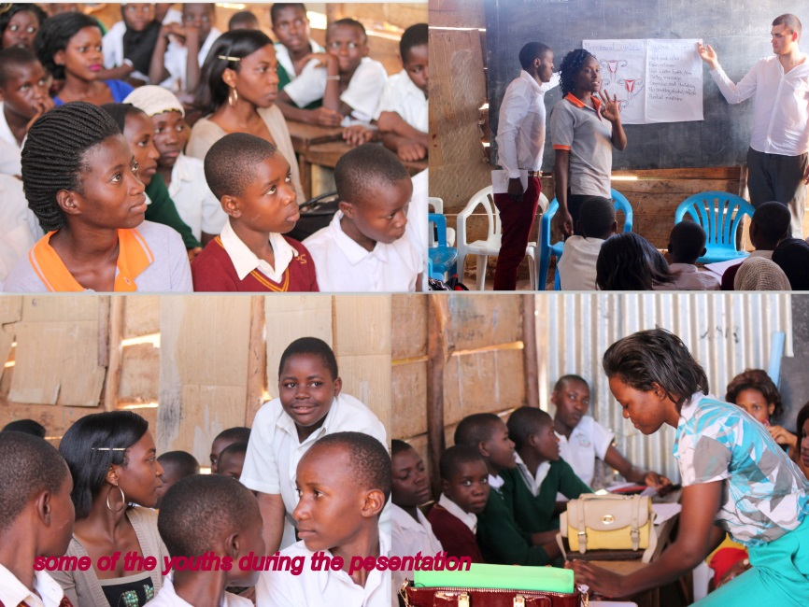
Methodology
The project was designed in such a way that workshops were held in schools, both primary and secondary in the slums of Kawempe division, to sensitize the students and pupils 10 years and above on menstruation and menstrual management. The project also included information gathering using a pre -designed questionnaire that was meant to find out how much knowledge and information the students had on the topic.
In primary schools, pupils from Primary five to Primary seven, girls only were targeted, while in secondary schools, students from S. 1- S. 3 were reached out to. 20 (10 primary and 10 secondary schools) Schools were reached with 800 participants (40 girls per school).
The facilitation methods used during the workshops included guided discovery, lecture, focus group discussions and experience sharing.

TOPICS
The information shared with the young people included the following:

Menstruation in general:
- Menstruation means a girl's body is physically capable of becoming pregnant. If you are not pregnant, once a month the unfertilized egg and the lining of the uterus mixed with blood is shed through the vagina. This is period.
- The start of menstruation is a major event in a girl's life. Some girls greet those first drops of blood with joy or relief, while others feel bewildered and scared. Whatever the reaction is it means the same: It's proof that she's becoming a woman and she can reproduce. So it means without them women couldn’t become mothers.

The female reproductive system:
- The female reproductive system includes a group of organs in a woman's lower belly. It's called the reproductive system because it supports the development and growth of a baby. This system is also responsible for a girl's monthly period. The female reproductive system has several parts.
- The uterus is where a baby grows. It is a hollow organ with a muscular wall.
- There are two ovaries, one on either side of the uterus. Ovaries make eggs and hormones like estrogen and progesterone. These hormones help girls develop during puberty, and make it possible for a woman to have a baby.
- Fallopian tubes go from the uterus to the ovaries. During the menstrual cycle an ovary releases an egg into the fallopian tube next to it.
- The cervix is the lower part of the uterus that opens into the vagina. During childbirth, the cervix expands, so the baby can go through.
- The vagina is a tube that connects the uterus to the outside of the body. The entrance to the vagina is on the outside of the body.
- During sex, sperm cells travel through the vagina to the uterus and fallopian tubes.
In the fallopian tube, the sperm meets the egg. If a sperm cell fertilizes the woman's egg, it's the first step in producing a baby.

The menstrual cycle:
The time between the first day of the period and the start of the next is called menstrual cycle.
- Pre-ovulation phase: During the menstrual cycle, hormones are released from different parts of the body to prepare the body for a possible pregnancy. Women and girls have two ovaries that contain thousands of eggs. During the pre-ovulation phase, hormones stimulate the development of eggs and the lining of the uterus starts to thicken.
- Ovulation: The release of the egg is called ovulation, and it happens in the middle of the cycle — for example day 14 of a 28-day cycle. From the ovary, the egg moves into one of the fallopian tubes.
- Premenstrual Phase: After ovulation, hormones trigger the body to continue developing the lining of the uterus, in preparation for a fertilized egg. During this phase, if you were to become pregnant, the egg moves into the uterus, and then attaches to the lining. If you are not pregnant, the egg begins to fall apart and the hormone level drops.
- Menstruation: If you are not pregnant, now the menstruation starts. The lining of the uterus mixed with blood leaves the body through the vagina— typically about a quarter of a cup of blood. The amount of blood varies between each woman; it can be light or heavy. The period will last between three to seven days.
Points to note:
The girls were informed that;
- The first day of bleeding is officially day one of the menstrual period. It’s also day one of your cycle (which ends on the first day of your next period.) The typical cycle of an adult female is 28 days, although some are as short as 22 days and others are as long as 45. For the first few years after menstruation begins, cycles are often irregular.
- Sometimes ovulation (the release of an egg from an ovary) can already happen before a girl got her first period. This means that she can become pregnant even before her first menstruation.
- Breast development and the growth of some pubic hair are usually the first signs that a girl has entered puberty. About 2 and a half-years after breast development started, the first period should arrive. But everyone is different, so don’t worry if you change more quickly or slowly than your friends do.
- A woman stops having her period usually between the ages of 45 and 51, which means she will no longer be able to become pregnant
- It is possible that your periods start with signs like mood swings and irritability, tension, bloating, and breast tenderness, what is totally ok and will go away after some days.
- You should understand that you can do everything you normally would do — as long as you feel comfortable.

Sanitary pads:
At this moment the girls were taken through steps of how to use a sanitary pad. They were informed that sanitary pads come in different sizes. They are placed in the pant and catch the menstrual blood to keep the pants clean.

- Take the sanitary pad out of the packet.
- Peel off the sticky strip in the middle.
- Put it longwise in your pants. The sticky strip will now keep it in place.
- If it has wings, they should be put around the underwear.
- Now you can get on with things and not worry about your period. The pad should be changed at least every 4-8 hours during the day.
- After using it should be disposed off in the dustbin.

- Wash yourself clean during your menstruation
- Pads aren't visible through clothing. So no one will know that you are using one.
- Carry always a few pads in your backpack, in case your period starts when you don't expect it. If your period surprises you, make a sanitary pad out of rolled up toilet paper and try to get a real sanitary pad as soon as possible. Or ask a friend or teacher if they have one for you.
- If you are afraid that blood could leak onto your pants, wear dark clothes during your period and if it happens tie a sweatshirt around your hip until you are able to change clothes.
- Don’t use dirty fabrics to catch the blood, it can cause vaginal infections
- Try not to stay at home during your menstruation. It has a bad impact for your education. If you use sanitary pads in a good way nothing can happen

How to sew reusable sanitary pads:

- Get a cotton cloth, wash it, dry it and iron it
- Cut it and shape it in an oval form
- Put cotton wool in the middle of the cloth and begin sawing
- Add the fiber/ kavera behind the sawed pad
- Cover it with another cotton cloth and ready to use.

Need to prepare the material before you begin on making a pad:
- Cotton and cotton cloth
- Scissors
- Needle and threads
- Fiber/kavera
- Razor blade

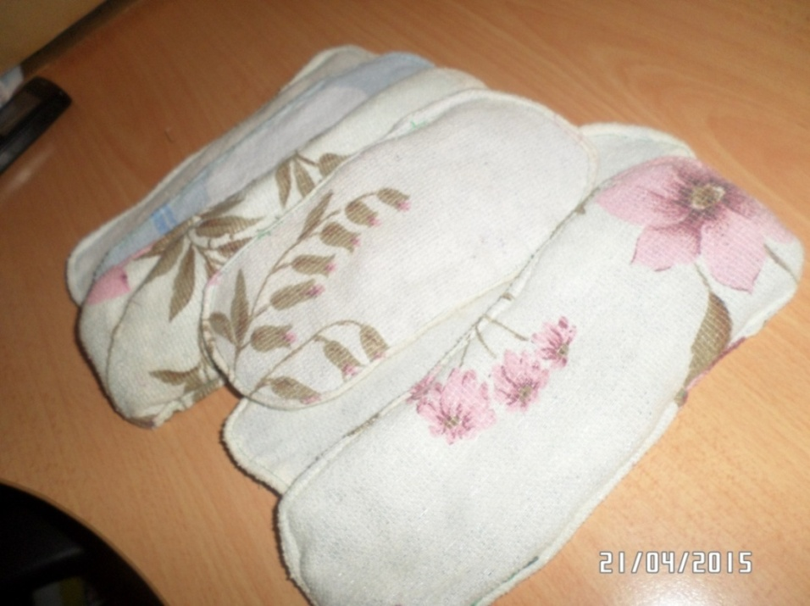
Above: A lady making resusable sanitary towels
Below: Resuable sanitary towels, ready for use.

Menstrual Cramps
- Menstrual cramps are pains, which some women get during her period. Normally it starts at the onset of the period and continue one to three days. It is caused by contractions in the uterus for pushing out the menstruation blood. This pain usually is felt in the lower abdomen or back, but it also can spread into the legs or stomach area. The strength of the pain depends on the woman, but they usually become less painful as a woman ages and may stop entirely after the woman has her first baby. But sometimes they are also caused by a disorder in the woman’s reproductive organs. The participants were informed that in case of severe pain, they should visit a doctor.

Participants were also given some tips on handling menstrual cramps, including;

- Rest and relax!
- Take pain reliever, the best directly at the time the pain starts coming.
- Place a hot water bottle on the stomach and drink tea.
- Massage the lower back and abdomen.
- Mild exercise and stretching
- Avoid smoking, alcohol and caffeine.
- Track your period, so that you know when the pain will start
- Herbal medicine

Challenges
The schools were requesting to postpone the activity to the following term, because at the moment, the students were about to sit for their end of term examinations. However we requested that we had it in our work plan to hold the workshops then and it would be something that we agreed upon. They however requested that in future Somero should present their work plan in the first term, to help them plan accordingly.

Results
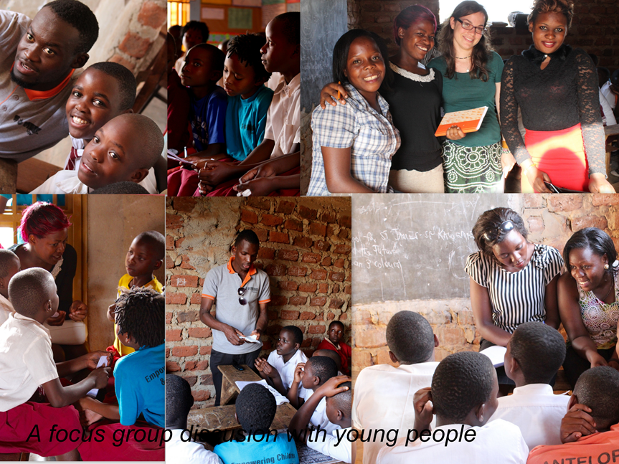
We talked to around 100 girls from two primary schools and one secondary school. The most Ugandan school girls, whom we talked to got their period with 13 years. The earliest got it with 11 years and the latest with 15 years. Most of them did not know what is happening with them, so they thought they got hurt and therefore they got very scared. Some even didn’t talk to anyone because of shyness. The ones who shared their situation talked to their mum, sister or aunty.

Most of them feel very uncomfortable if they are in school during their period, because “a lot of teachers don’t believe and cane you though, if you say you are in your period and you don’t want to participate in sports or games and of course you feel more comfortable at home”. But still they try not to miss classes because of being in their period, also if they get problems like head age, stomach pain, lack of sanitary pads, etc. The most of the girls use sanitary pads, but if they don’t have money they use old fabrics or a hankie, what can cause vaginal infections. Two of the three schools don’t provide any health facility or medication, and one of them brings the children to a clinic, which is close by or even helps with some painkillers.

The girls also told us about some cultural taboos or recommendations; for example they are supposed to count the bricks in the house when they get their first drop to help them know how many days they will stay in their menstruation. Another taboo is that they “should not go in junctions” or touch the Holy Book.
When the girl gets her first drop, she is taken to her aunty or grandmother. The society expects her to give birth because now she is grown up. During a girl’s period she is not supposed to do hard work.

Through talking to the school leaders and the girls, it was realized that the sanitary facilities are very poor equipped, so that it is very unhygienic for girls to change their sanitary pads there. It was also revealed that most girls put their used sanitary pads into the latrine because they fear that someone could take them out of the dustbin and show them around. But then the latrines get stuffed very fast and the school has to face another problem.
Conclusion
Somero Uganda wishes to continue with this project, but through training around 20 peer educators to get a good knowledge about this topic and to equip them with the necessary materials, and then send them to the different schools. Also the school girls can talk to other peers which in their communities about the topic.

