Name: AnninaLiethof
Linda Schonewille

Date: 15.june.2017

Version: 1.0

Somero Uganda
May 2017

Table of content
1. Acknowledgements 2
2. Management summary 2
3. Problem statement (and research objectives) 2
4. Description of the activities/interventions 3
5. Conclusion & Recommendations 3
6. Recommendations for future activities/interventions 3

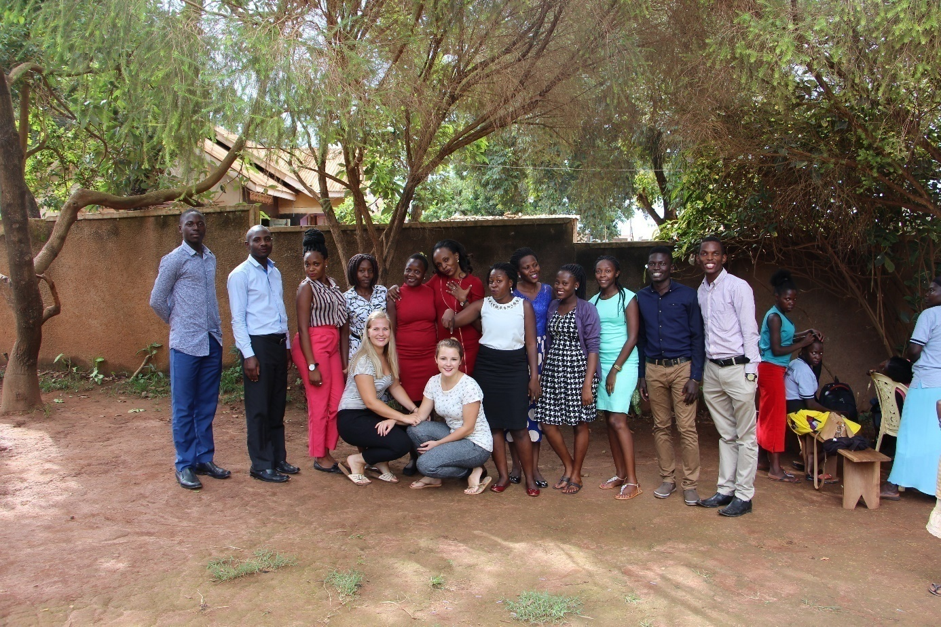

1. Acknowledgements
We wish to thank Somero Uganda for their open attitude towards us, the space given to us and letting us think about different activities and helping us with our school assignments more than we anticipated. There was always an answer to every question, infact “more answers than the questions.”
We have gained new knowledge, we learned a lot about the culture and how different things work out in Uganda . It was so inspiring.
We also want to thank our supervisor coach; Susan Geurts and individual supervisor; Anna van Brakel for the educational meetings, because of them we have gained new insights.

2. Management summary
Somero is a beautiful organization with many oppotunities and possibilities. They devote every effort to educate youth, training them, health counselling about HIV/AIDS and personal hygiene and various edutaining games during liesure time. We find this great to see that these people also get new inspiration and knowledge. Contrary to what is done in Netherlands, your sessions involve large groups that is above thirty participants, this limits participation and involvement since some might miss out some information and give an overview for the whole group. You find that people at the front are attentive and active while those at the back are diverted to other things like gossiping and other irrelevant conversations. Its better to split them into smaller groups for more involvement and participation. It is important that all class issues and materials are used, conducted and contained within the class.
We made an educational HIV game, you can play it with a maximum of eight people. This means that you are required to play it in small groups, we hope that they play the game often and that they can see that it’s better to work with small groups.

3. Problem statement (and research objectives)
We worked on different activities and we don’t have one specific project. The main project was HIV, we made an educational game for it. We have chosen a game, because it helps the students learn a lot about HIV in a fun way during leisure, they can ask questions and other people can answer their questions. Though we were busy with presentations, home visits, we learned the most about the culture, how they work and what a social worker is in Uganda. Our time here will hopefully provide information through presentations in smaller groups and the use of our HIV game.

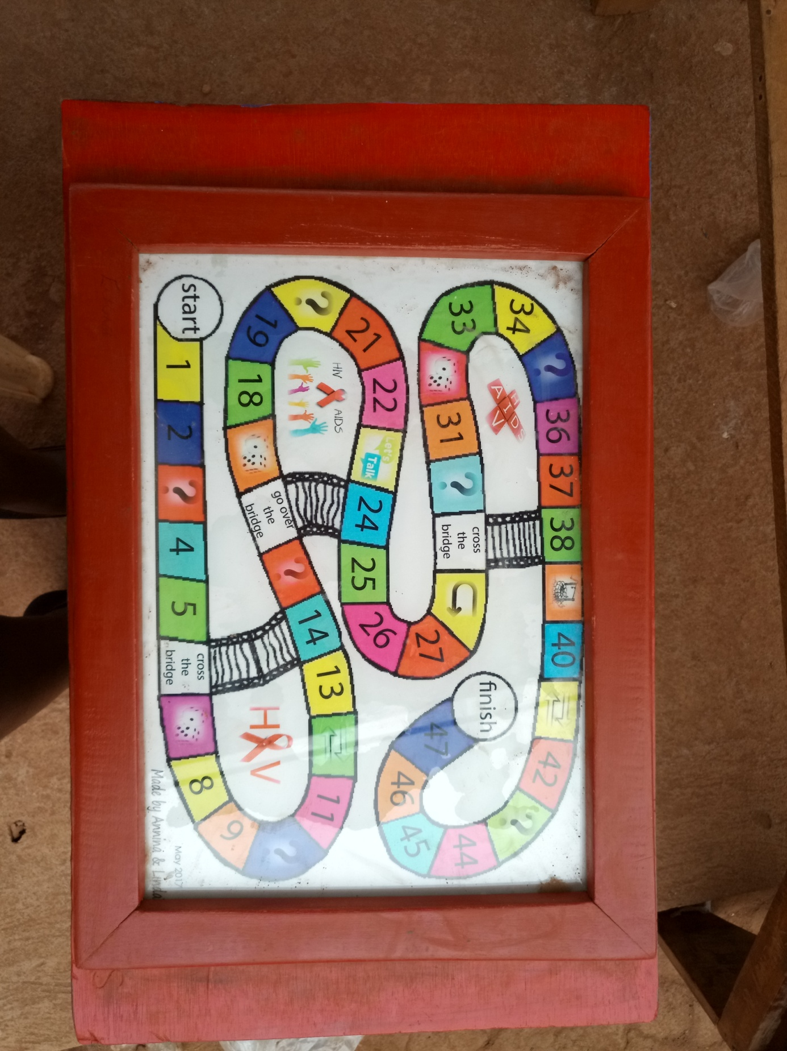

4. Description of the activities/interventions
We had a lot of activities and interactions during our internship at Somero Uganda. We have made presentations, designed two games, we visited different homes, schools, hospitals and other organizations, demostrated about violence, attended a day against environmental pollution, various types of meetings, attended a session in the graphics class, have participated in various proposal writing meetings, visited the police, we sported with the children and also played games with them. We have worked extensively with the social workers from Somero Uganda. We experienced this as very pleasant, they had enough knowledge to help us and provide information. In addition, we have worked a lot with the teacher of the graphics class and Geofrey and Irene could always answer our questions.

5. Conclusion & Recommendations
Our conclusion is that Somero Uganda is a very good organization, with good hardworking employees and they stand open to new ideas. We felt like home while at Somero, we were accepted into the team and got a safe feeling, thanks for the hospitality.
We hope that in the future you will give information through presentations in smaller groups (up to thirty) and that they will realize that this is more effective/efficient.
Some times it was difficult for us to take a lot of initiative by ourselves because we didn’t know what to do because we are not familiair with the Ugandan culture and we were not certain of the “right” thing to do. In addition, at the beginning we didn’t know what Somero wants, what could we do and what not.

What we would like to make clear is that we don’t make proposals in the Netherlands if you are a nurse or a social worker, so we don’t have any knowledge about it. We would like to learn new things though it’s not included in our education.

6. Recommendations for future activities/interventions
We hope that the next students who are going to do the internship at Somero also have a beautiful and educative time as we had. Hopefully they can see if it’s possible to give a presentation in small groups (up to thirty) and keep playing our game. It is also important that they asertain what they want to achieve before they start with their internship. In addition we just want to say, ENJOY!!

