SOMERO UGANDA
GIRLS ON THE MOVE, INTERACTIVE PREVENTION OF SUBSTANCE ABUSE IN BWAISE II &III, KAWEMPE DIVISION.

PROJECT REPORT
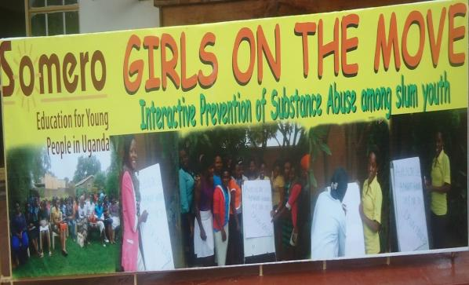
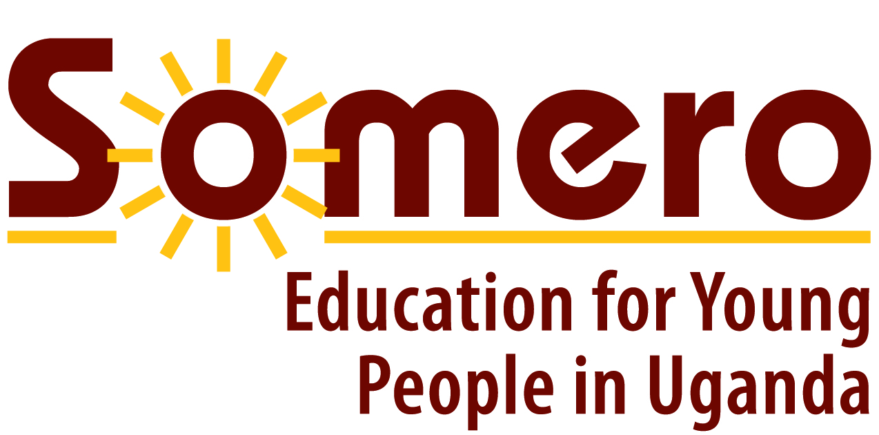
P.O BOX 16488 Kampala, Uganda.
Located Bwaise, Mukalazi road, off Jakana road after Kawempe police Station.
Website; www.somero-uganda.org.

Introduction

Somero Uganda is a grassroots registered organization founded in 2009, with a vision of a Uganda where girls and boys 10-25 years achieve meaningful education and training needed for a self-determined and self-sufficient life to act as agents of social change with full community support.
Her mission is to offer specific education and training programs, life skills development and health promotion among vulnerable children and young women with a mobilized community support including boys and young men.
In 2015 the organization implemented a project “Girls on the move”, Interactive Prevention of Substance Abuse with in the slums of Kawempe division funded the United Nations Office on Drugs and Crimes (UNODC). In line with the project, Somero Uganda’s objectives are to increase access to appropriate skills training and develop programs that young people are employed without being exploited, to increase information and on the prevention of drug abuse and substance abuse and other social issues and to mobilize an integrated community in promotion of education and supporting youth to rehabilitate.

The specific objectives of the project were to
- To educate 400 young people of ages 15 – 25 per year in 2 slum areas in Kampala (Bwaise 2, Bwaise 3 in 2015) on the subject of substance abuse, through creating an exhibition using the power of photographs, narrative stories and music while providing interactive education information delivered by trained facilitators with the aim to give to the youth an opportunity not just to learn, but also to practice skills concerning prevention.

- To form sustainable community youth clubs organized by trained young peers, focused on the prevention of substance abuse in these 2 areas with the vision of providing them clear information on the subject and a place of psychosocial support from professionals.

- To equip and empower 20 peer girls involved in Somero ICT Development Program and photography class with additional skills in the area of journalism, but also in planning, organizing, managing, implementing and the evaluation of the project. Furthermore, the trained students will be able to train others in the slum area and hence become agents of social change.

- To connect participating youth to other activities of UNODC Youth Initiative via social media such as Face book.
This report provides a documentation of the project implementation and impact.
The Target population.

The project worked directly with 20 young women involved or at risk of commercial sex exploitation as direct beneficiaries. These are young Women ages 15 – 25 living in the slum areas of Kawempe Division Kampala. These were equipped with peer education skills using the power of photography and reached out to 400 other youth in their communities as indirect beneficiaries.

The indirect beneficiaries are the 400 young people reached out by the 20 direct beneficiaries. These were reached out through the exhibitions and clubs. Among indirect beneficiaries are community members, as well as friends and family members of youth, whose attention was drawn towards the subject of drug abuse and its necessity to implement prevention activities in their area.
In general this project is supporting the development of selected slum areas in Kampala. The project concentrated on only two parishes of Bwaise 2 and Bwaise 3 in Kawempe division Kampala, Uganda.

Project Activities
To achieve the objectives the project implemented different activities
20 young girls equipped with photography and journalism skills
The 20 direct beneficiaries involved in the project were young women involved or at risk of getting involved in commercial sex exploitation and were already active in the Somero Uganda’s ICT skills development program.
The project equipped the girls with photography skills as a communication tool. The girls learnt how to take communicating photographs that could attract attention of young people and the community at large. The skills development took two months. During the same time issues of substance abuse were discussed into wider knowledge and understanding. The girls develop different concepts of interest and were eager to find out what happens in the community. The topic was about the causes and effects of drug abuse among youth and a semi structure questioner was developed as a guideline.

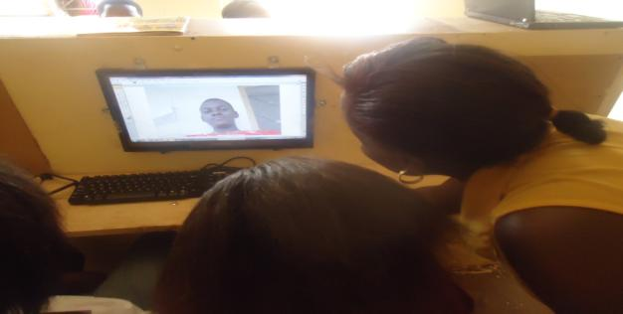
Above; Pictures showing the girls during the training sessions
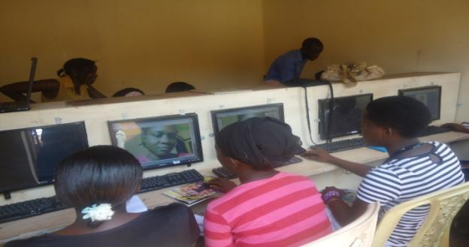

20 girls apply gained skills in their communities
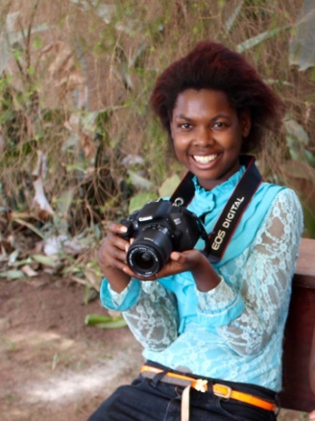
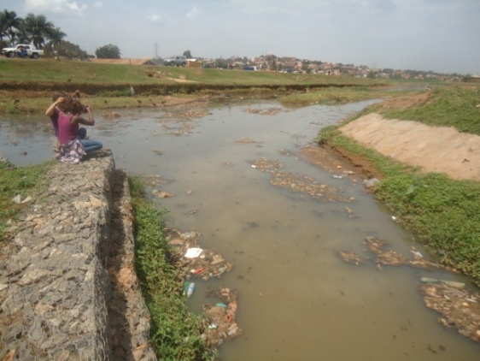
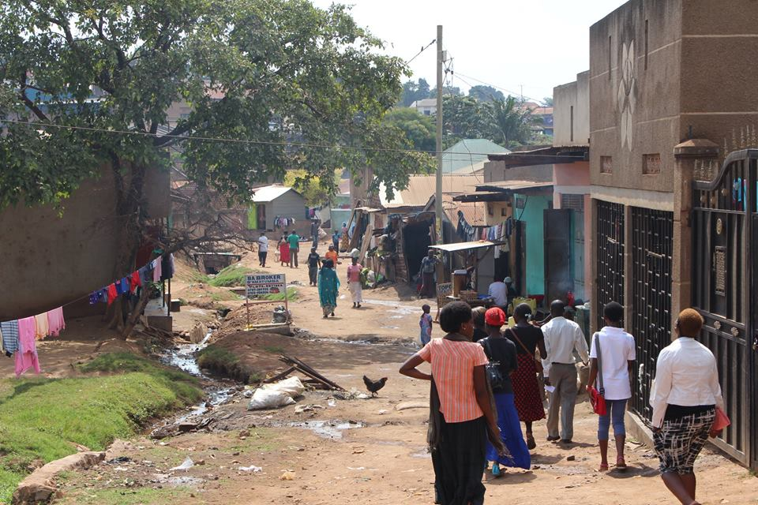
When the training was completed, the 20 Somero girls were sent into their communities with cameras and semi-structured questioners to discuss with local people on the issue of substance abuse. The goal of this activity was to collect different stories concerning the issue of alcohol, tobacco, drug abuse, but also dealing with non – medical use of prescription drugs and the abuse of inhalants. This was easy because the girls know the area very well as they are coming from the same communities. The community members were willing to share freely and the girls documented their stories both in a photographic and a narrative way. Male and female, different age groups, marital status, professions and hobbies were interviewed.
Above; Pictures showing the girls in the community collecting different stories concerning about the topic. Below are some of the photos taken by the girls from the communities?

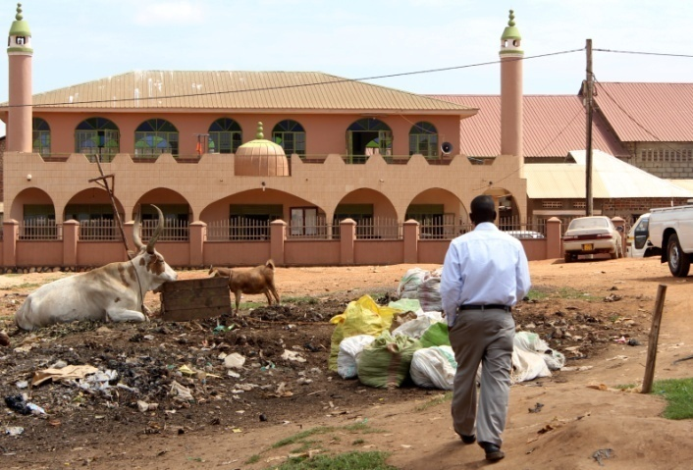
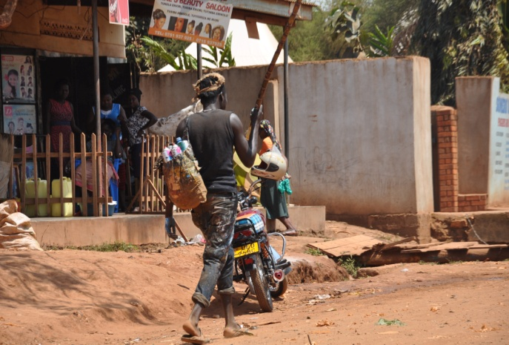

Creation of a masterpiece on substance abuse
After gathering information, the girls created different photo masterpiece out of their time in their communities using computers for putting together photographs, personal stories and educating information dealing with the problems of substance abuse under the guidance of the project coordinator. The results of this were 20 edutainment posters with photos and wordings providing information about drug and substance abuse.
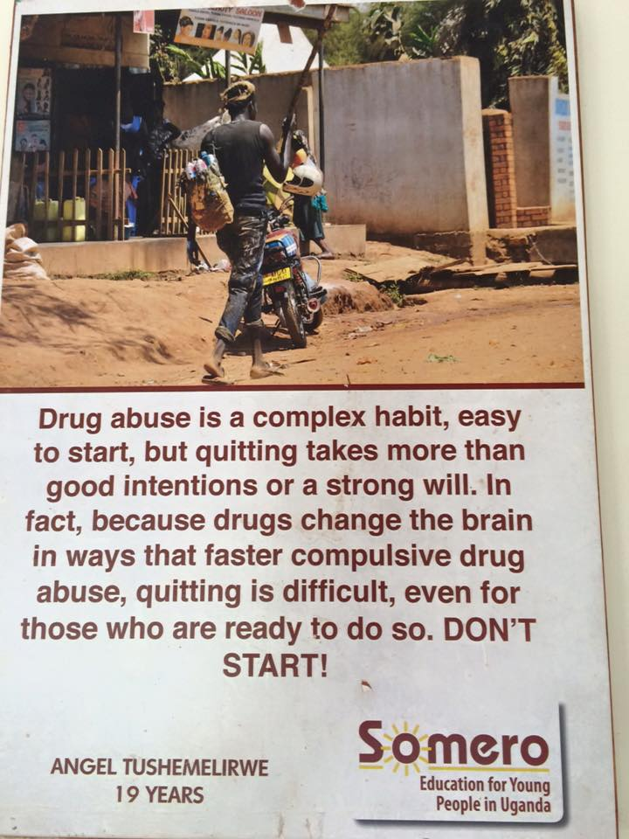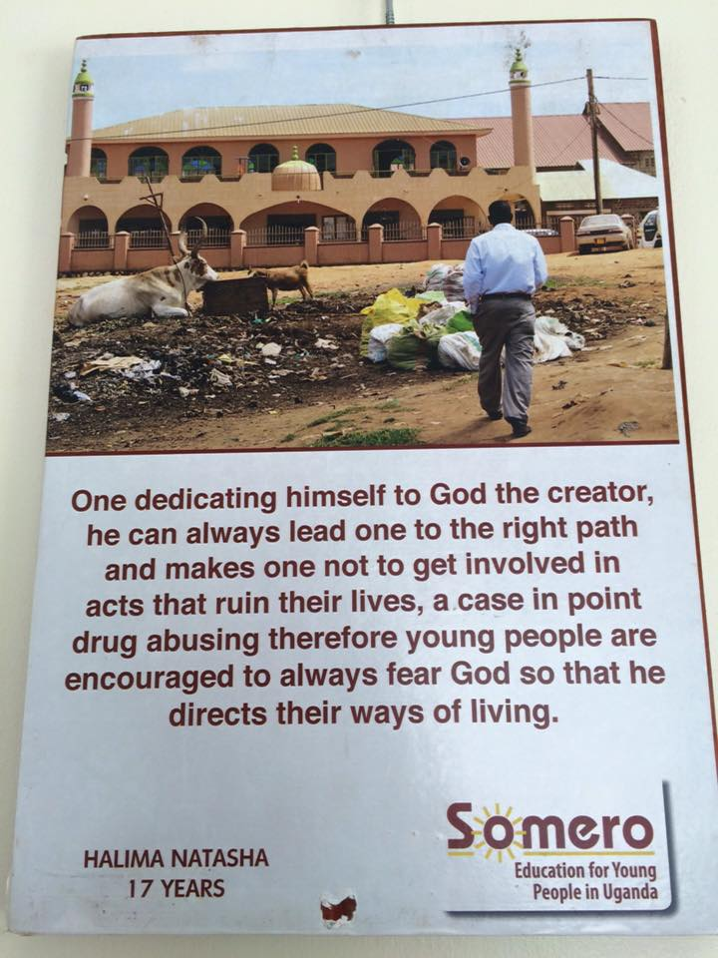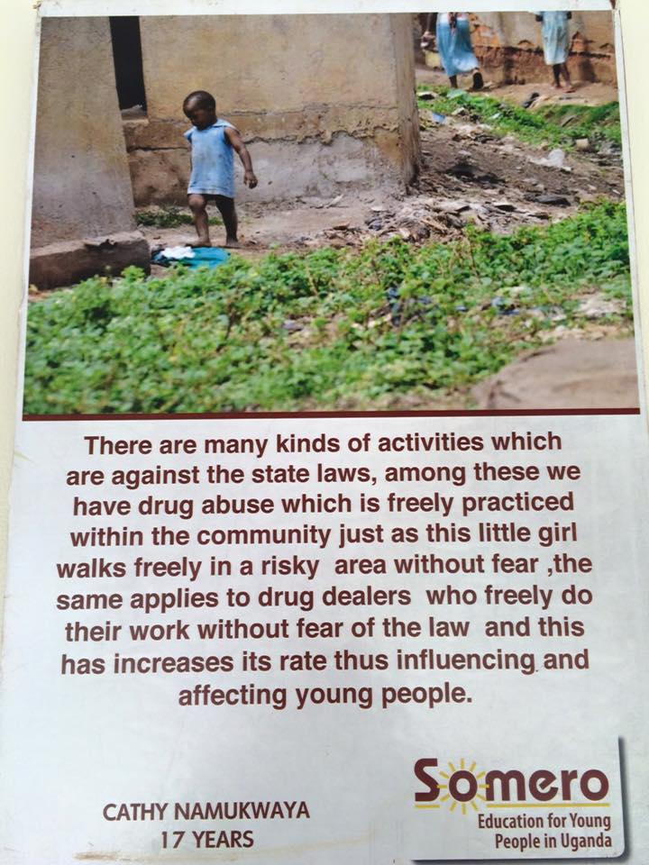

Community educative and youth focused exhibition is organized

The 20 posters were used to organize 4 community exhibitions. The 4 exhibitions were organized by the 20 girls in their slum areas. The exhibitions were in Mukalazi Zone and Tebuwoleka Zone in Bwaise 2 parish, Kamalimali and Katoogo zone in Bwaise 3 parish the exhibitions were attended by 111, 93, 102 and 121 young people respectively. The exhibitions were focused on the prevention of substance abuse, using stories collected by Somero girls and providing educational information. On special Occasions, the girls also exhibited outside their communities during including the National youth day and the No Alcohol day 18th December
Somero worked closely with Uganda Alcohol prevention Alliance (UAPA), where is already a member, to provide motivational speakers. Also through a strong partnership with Uganda Youth Development Link, an NGO which has vast knowledge about the subject, Somero Uganda invited professionals to draw attention to the community to provide them clear educational information. Musical performance and interactive lectures were delivered by trained facilitators.

The youth enjoying games at the exhibition during the games competitions, left The Executive Director of Kampala Capital City Authority in a Photo exhibition

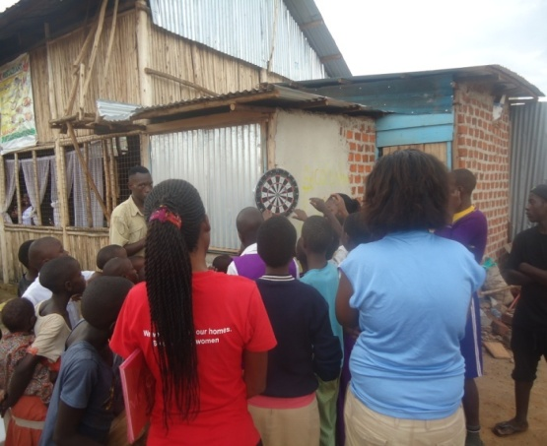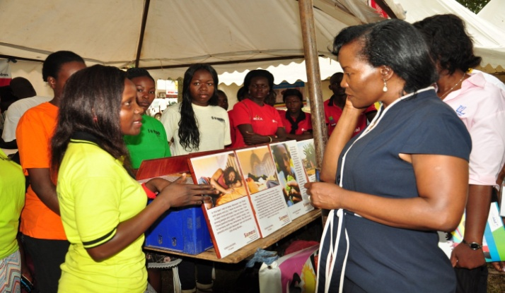
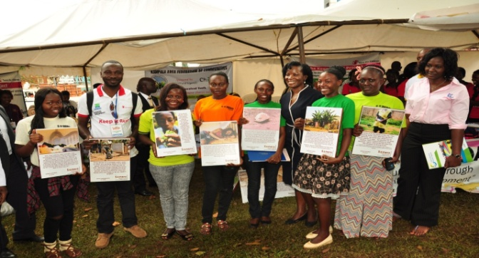

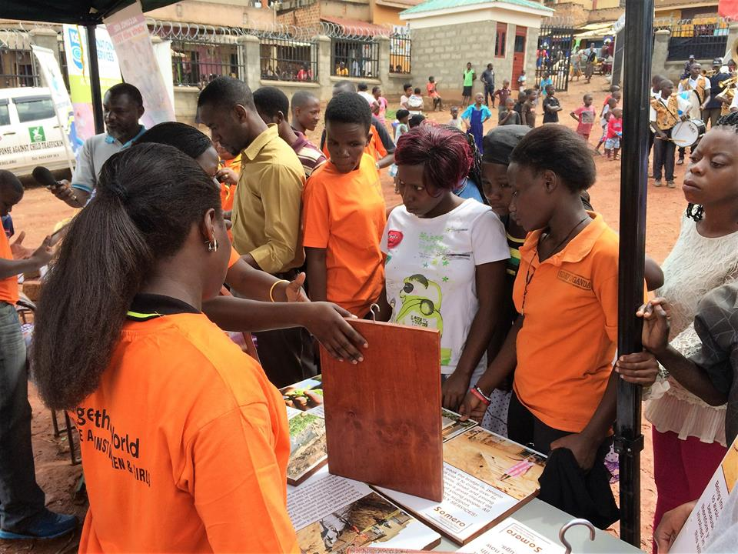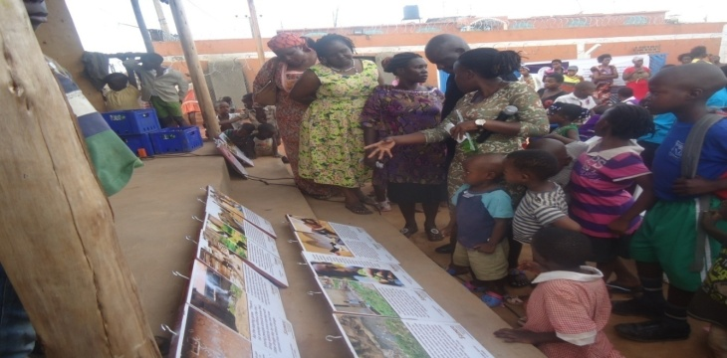

The girls on the move showing off their photos during the photo exhibition, below guests going through the photos that were exhibited

Creation of Community Youth Clubs
During the exhibition the 20 young women also talked to the attending youth to interest them to join youth clubs. 2 clubs were formed in each target slum and these clubs meet once a month. In their meetings information on positive, healthy and safe lifestyle are discussed. Members are encouraged and supported not to use drugs. Fun free time activities including board games, music dance and drama as well as community outreach programs are also organized. Visiting professionals are invited to talk to the members and time is also given for a one on one talk and counseling.
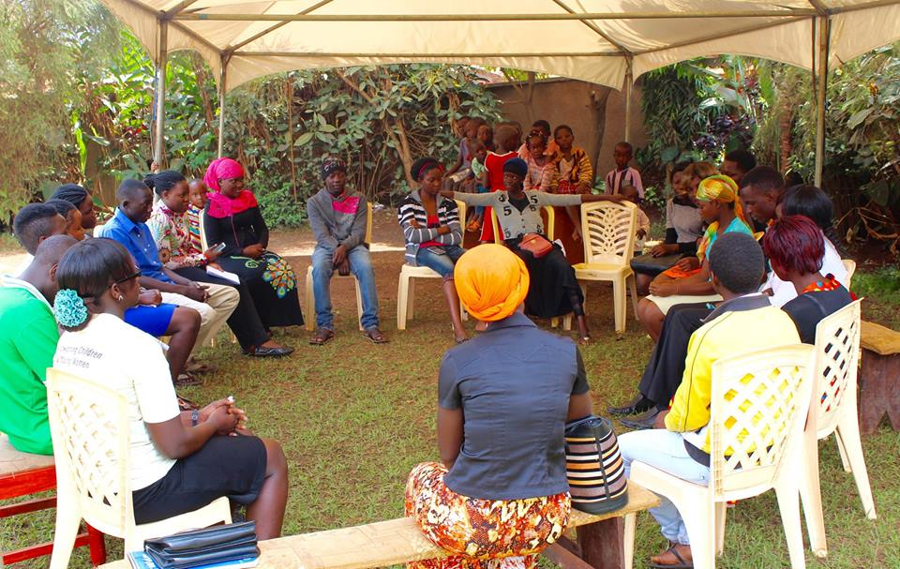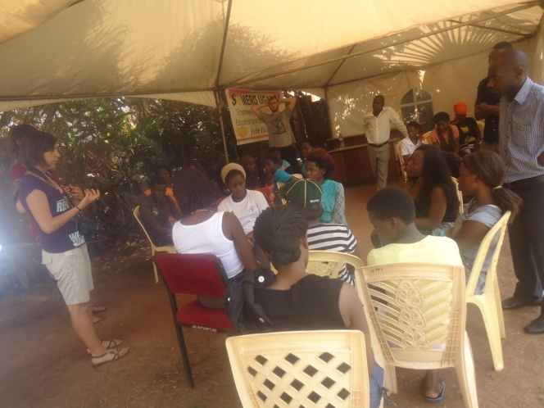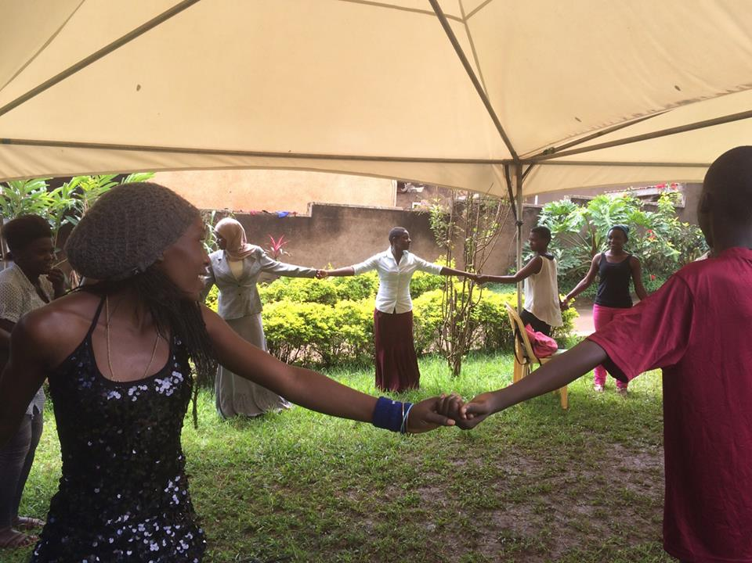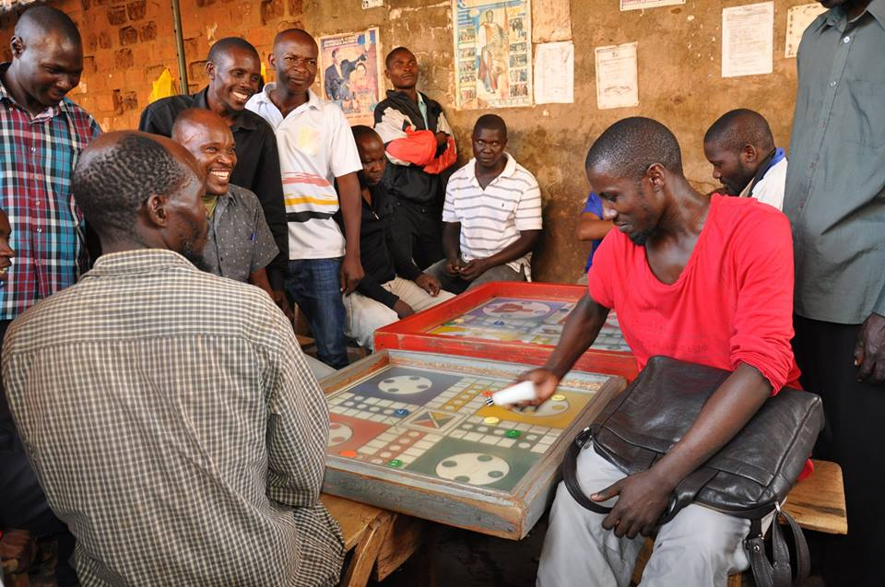
Orientation meeting for the youths after the formation of the groups

Above Young people during a group meeting, below youths enjoying energizers during the group discussion
Community members enjoying luddo

Creating Community Posters
The clubs have also been supported to create one community posters following the information on substance abuse discussed throughout the year. These posters have been painted on the wall in forms of murals on the target slum area where they are easily accessible to the community. They are interactive and easy to read.
The members also produced and printed a magazine to share information to other youth. A few copies were printed and shared among other youth groups as well as putting a copy on different online platforms.
The Impact of the Project
- The project has connected youth to other groups both online and within the community who participating in the drug abuse prevention projects.
- The participating youth have gained more information about drug abuse prevention and confidence to reach out to fellow youth. Skills of peer education were also acquired.
- Meeting places have been setup in the area where the youth can meet to discuss and participate in activities that can help them to prevent abusing drugs.
- A strong network among youth groups has also been created.
Project Continuity
This project will continue naturally through the youth clubs formed. The clubs shall perform different activities as the wish and Somero Uganda shall continue to guide them.
At the Somero center a new group of young girls shall continue to participate in the development program, specializing in the area of photography each. Every year Somero can work with 20 of these girls in collecting photographs, stories and creating masterpieces. These peers will work each year in slum areas which participated in this project in the past with already established youth clubs, but will also carry out exhibitions in 2 new slum areas per year establishing at least 2 new clubs.
The club members shall also continue to access in the photography equipments to practice and gain skills that they can use to sensitize more youth.
Annual reports about the activities of the clubs shall be compiled and distributed to stakeholders of this project, partnership organizations and other supporting individuals. This shall be done in a soft copy.
Somero has the vision of establishing this project as a sustainable activity
Conclusion
In general the project was successfully implemented; we would like to thank the staff and volunteers, the participating youth, the community members, donors-UNODC, the Uganda Alcohol Policy Alliance, and stakeholders of the project, partner organizations and other supporting individuals

