SOMERO UGANDA
Teaching and Learning-IT women empowerment project
(June –December 2013) Data analysis report.
By
Betty Flora Akello
2/7/2014
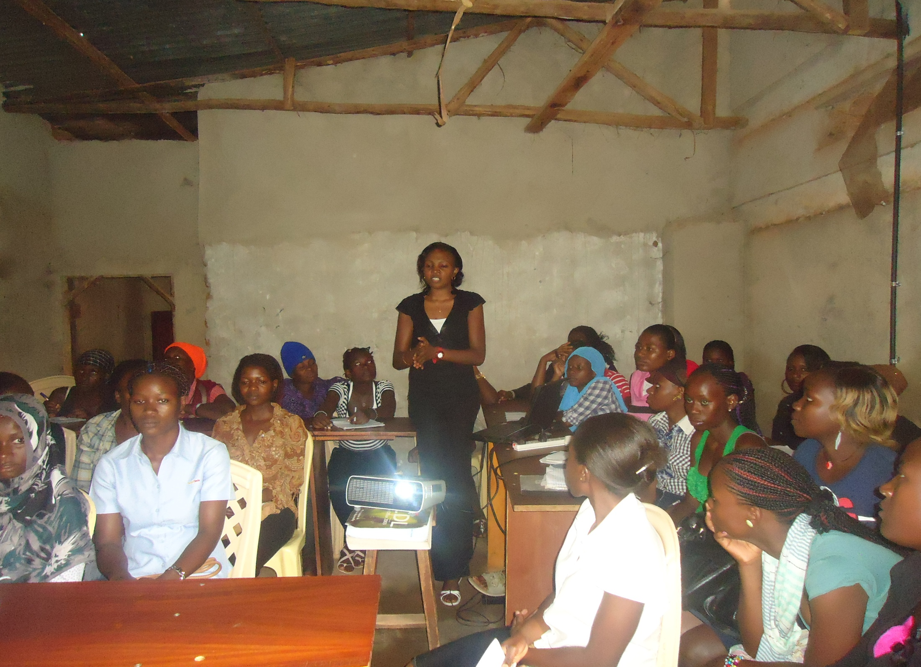

FOR

SOMERO UGANDA

This Report analysis seeks to expose the general characteristics of the 55 girls and young women trained in the June - December 2013 intake. Registration forms with leading questions were administered in form of an interview guide to the beneficiaries with the help of the Somero team, to establish the information about the group and the data collected, was analyzed to come up with the following findings.

TABLE OF CONTENTS
Page
INTRODUCTION…………………………………………………………………………………………………………………………..................3
PERSONAL DATA…………………………………………………………………………………………………………………..…....................3
PROVENIENCE OF THE YOUNG WOMEN………………………………………………………………………………….…..………………4
FAMILY SIZE………………………………………………………………………………………………………………………..........................5
MARITAL STATUS………………………………………………………………………………………………………………………..................6
EDUCATION BACKGROUND/LEVEL COMPLETED………………………………………………………………………………..........8
REASONS FOR SCHOOL DROP OUT……………………………………………………………………………………………………………..9
WISHES OF THE GIRLS AND YOUNG WOMEN…………………………………………………………………………………………….10
TRAINING ATTAINED AND WORK EXPERIENCE…………………………………………………………………………................11
LEISURE ACTIVITIES ENJOYED……………………………………………………………………………………………………..……………..12
REPRODUCTIVE HEALTH…………………………………………………………………………………………………………….................12
OTHER USEFUL INFORMATION…………………………………………………………………………………………………………………..14
LINK TO SOMERO UGANDA………………………………………………………………………………………………………………………..15
TRAINING SESSIONS……………………………………………………………………………………………………………….. ………………..16
HOW THE SKILLS WOULD BE USED …………………………………………………………………………………………………............17
CONCLUSION………………………………………………………………………………………………………………………………………………18
LIST OF TABLES
Table 1: Age distribution…………………………………………………………………………………………………….………….3
Table 2: Provenience of the young women…………………………………………………………………………….........4
Table 3: Family size………………………………………………………………………………………………………….…………….6
Table 4: Marital status ………………………………………………………………………………………………………………….6
Table 5: Categories of unmarried young women………………………………………………………………..…………7
Table 6: Education Background/ Level completed …………………………………………………………………………8
Table 7: Reasons for school drop out …………………………………………………………………………………………..10
Table 8: Wishes of the young women…………………………………………………………………………………………..11
Table 9: Sexuality………………………………………………………………………………………………………………………….13
Table 10: Sexual activity of the young women………………………………………………………………………………14
Table 11: How the skills would be used………………………………………………………………………………………..17
LIST OF FIGURES
Fig 1: Age distribution…………………………………………………………………………………………………………………….3
Fig 2: Areas of Provenience………………………………………………………………………………………………………......5
Fig 3: Family size………………………………………………………………………………………………………………………......6
Fig 4: Marital status……………………………………………………………………………………………………………………….7
Fig 5: % categories of the young women……………….………………………………………………………………………8
Fig 6: Education Background/ level completed …………………………………………………………………………....8
Fig 7: Percentage of school drop out per year …………………………………………………………………………….10
Fig 8: Wishes of the young women………………………………………………………………………………………………11
Fig 9: Reproductive health Education ………………………………………………………………………………………….12
Fig 10: Sexual activity ………………………………………………………………………………………………………………….13
Fig 11: Link to Somero …………………………………………………………………………………………………………………16
Fig 12: Training sessions ………………………………………………………………………………………………………………16
Fig 13: Skills use after training………………………………………………………………………………………………………17
INTRODUCTION
Between the months of June and December 2013, Somero Uganda reached out to a total of 55 young women beneficiaries between the ages of 16 and 25 years, who were registered for the ICT skills development course at the centre. Assessment of the beneficiaries was made through forms with leading questions to obtain the required information, that included their personal data, their family background, the education background, if working what experience they had so as to become useful to the rest of the others, their interests, information about their sexual reproductive health, individual choice of the training sessions, how they found their link to the Somero centre and skills use after training. From the raw data collected by the Somero team, the following analysis was made to answer the questions required to get the right picture of the beneficiaries trained in the June-December Teaching and Learning- IT women development project intake.
PERSONAL DATA
Out of the 55 young women trained between June and December, 3 were 16 years, , 11 of them were 17 and 20yrs, 4 were 18 and 22years, 5 were 21 years, 13 of them were aged 19yrs, 2 were 23 years, while 1 was aged 24 and 25 each. The youngest of the young women trained was 16 years and the oldest 25years.
Table 1: Age distribution Fig1: Age distribution
Age group | N0 of girls
16 | 3
17 | 11
18 | 4
19 | 13
20 | 11
21 | 5
22 | 4
23 | 2
24 | 1
25 | 1
Total | 55

PROVENIENCE OF THE YOUNG WOMEN
By provenience, most of the young women came from the near by areas around the Kawempe slum/ division, the biggest percentage of the young women out of the registered 55 beneficiaries, came from the Kawempe slum area that includes Bwaise, Kawempe, Kawempe tula, Lufula, Lugoba, Kawempe Mbogo, Nabweru, Kazo Angola, Kawaala, Makerere kikoni and mawanda road with a total of 51 young women from these areas to make the highest percentage of beneficiaries of 92% and other areas like Namungoona (1), Maganjo (2), and kagoma (1), only 8% of the total number of beneficiaries.
Table 2: Provenience of the young women
Provenience of girls | No. | Provenience of girls | No.
Bwaise | 3 | Namungoona | 1
Kalerwe | 2 | Mawanda road | 1
Kawempe | 16 | Kazo | 12
Lufula | 1 | Kawaala | 1
Kagoma | 1 | Mengo | 1
Kawempe Tula | 2 | Nabweru | 1
Lugoba | 8 | Maganjo | 2
Kawempe Mbogo | 2 | Makerere Kikoni | 1
TOTAL | 35 | TOTAL | 20

NB GRAND TOTAL=55 Girls and young women

Fig 2: Provenience

From the 55 girls and young women reached, 22 beneficiaries were orphaned by either one or both parents, 8 of them were total orphans while 6 had lost only their mothers and the 8 had lost their fathers. However, the other 33 of the total group reached still had living parents of which 5 lived with boyfriends and 28 still lived with their parents/ relatives within the slums of Kawempe and the surrounding areas.
FAMILY SIZE
Family size ranged from 1 person to 15 other people living with the beneficiary and according to the analysis made from raw data collected from the target group, 53 beneficiaries lived with at least less than 10 other people, between 1-8, making a percentage of 96% of the total beneficiaries and 4% lived with more than ten people, 11 and 15 other people. The highest number of respondents however lived with eight other members of their families.

Table 3: Family size Fig 3: Family size
Family size | N0 of girls
One | 2
Two | 5
Three | 6
Four | 10
Five | 2
Six | 8
Seven | 5
Eight | 15
Eleven | 1
Fifthteen | 1
TOTALS | 55

MARITAL STATUS
Out of 55 young girls and women, 2 were married and lived with their husbands as the other people, these made a percentage of 4% leaving the 96% of the target group unmarried. However of the 53 unmarried young women, 5 young women lived with their boyfriends with child or a relative, a percentage of 9%, 20 of them shared room with friends in groups of three, four and five within the Kawempe slums making a percentage of 38%, while 28 of the unmarried young women still lived with their parents or relatives to make a percentage of 53%.
Table 4: Marital status
Status | N0 of girls | %
Married young women | 2 | 4%
Unmarried young women | 53 | 96%
Totals | 55 | 100%

Fig 4: Marital status

Table 5: Categories of unmarried young women
Category |  | N0 | % | Classification of the unmarried young women
Unmarried girls and young women | OUT OF 53 | 5 | 9% | Unmarried living with boyfriends
 |  | 20 | 38% | Unmarried sharing room with friends within the Kawempe slums and sorrounding areas
 |  | 28 | 53% | Unmarried still living with parents/relatives
TOTALS |  | 53 | 100%

Fig 5: % categories of the unmarried girls and young women

EDUCATION BACKGROUND
The young women enrolled for the teaching and learning-IT women empowerment project training in the month of June comprised of mostly Ordinary level leavers with a total percentage of 78%. In terms of levels completed, 34 young women had completed S.4 making a percentage of 62%, 7 dropped out after S.3 to make 13%, and 2 left school in S.2 which is 3% while 12 young women with a percentage of 22% completed Advanced level of education.
Table 6: Education Background
Class completed | S.6 | S.4 | S.3 | S2 | Total
Actual number of girls | 12 | 34 | 7 | 2 | 55
Percentage | 22% | 62% | 13% | 3% | 100%
(%)

Fig 7: % of school drop out per class

REASONS FOR SCHOOL DROP OUT
From the data collected, 35 young women who made a majority of the total number reached in June, left school in 2012 with 11 leaving school in 2011, 6 dropped out in 2010, 1 in 2009, 1 in 2008 and 1 in 2006. The young women gave various reasons for dropping out of school, 25 suffered financial constraints after the loss of a job by a father, father got an accident, death of a father and the mother could not pay fees, 10 left after testing positive to a pregnancy test in school, 2 had to drop out after the death of both parents, and 2 were forced to leave school after losing their mothers, leaving them entirely responsible for their siblings at home.
However, it was surprising to note that 16 of the young women reported neglect by their parents whose attitude towards girl child education was still negative and admitted to have been discouraged by their parents from continuing with higher levels of education, with claims that the levels attained by their daughters were satisfactory to them. This reason applied to most of the young women who had completed S.6 and many who had completed S.4, reported the level attained was satisfactory to their parents.

Table 7: Reasons for school drop out
Reasons | N0 of girls | %
Financial constraints after father's loss of job/ an accident/ death , mother could not pay fees | 25 | 45%
Household responsibilities after Death of mother, had to look after siblings | 2 | 4%
Neglect and Poor attitude towards education by parents/relatives | 16 | 29%
Pregnancy | 10 | 18%
Death of both Parents | 2 | 4%
TOTAL | 55 | 100%

Figure 8: % of school drop out per year
YEAR | No | %
2012 | 35 | 64%
2011 | 11 | 20%
2010 | 6 | 10%
2009 | 1 | 2%
2008 | 1 | 2%
2006 | 1 | 2%
TOTALS | 55 | 100%

WISHES OF THE YOUNG WOMEN
Out of the 55 trained girls and young women, 27 of the young women which is 49% wished to go back to school for different careers ranging from Law, accountancy, secretarial studies, social work, developmental studies, nursing, Education, journalism, engineering, Mass communication, Medicine, computer science, fashion designing, business administration, as well as continuing with Advanced level of secondary education. While the remaining 28 a percentage of 51% did not wish to go back to school because of different reasons, 16 of them were convinced by her parents not to continue to higher levels of education, 2 were left with a lot of household responsibilities after their loss of either one or both parents, while the other 10 had vowed never to go back to normal secondary schools because of intimidation, shame and discouragement, after they were asked to leave school when found pregnant.
Table 8: Wishes of the young women
Wishes | N0 | % |  | Reasons
Wish to go back to school | 27 | 49%
Do not wish to go back to school | 28 | 16 | 29% | Poor attitude towards girl child education by parents (neglect, conviction, discouragement)
 |  | 10 | 18% | Pregnancy
 |  | 2 | 4% | Household responsibilities after loss of parent(s)
TOTALS | 55 | 28 | 100%

VOCATIONAL TRAINING ATTAINED AND WORK EXPERIENCE
Out of the 55 trained young women, 3 had attended a vocassional skills training institution before joining Somero and they had skills from different institutions in Nursery teaching, Hair dressing, and Primary school teaching and they were still employed while at the training. Two other working members of the group acted as helpers in shops which made a total of 5 working young women, a percentage of only 9% of the reached group and this left 91% of the beneficiaries without any skills or work experience.

LEISURE ACTIVITIES ENJOYED.
Leisure activities of the young women included chatting and visiting friends, listening to music , reading Novels, dancing, singing, composing songs, watching T.V, while others still did productive work as they relaxed like looking after their siblings, helping with house work, selling items and operating a telephone booth.
SEXUAL REPRODUCTIVE HEALTH
A total of 36 girls had sexual reproductive health education that they got from mostly their former secondary schools before they left, between the years 2006-2012. Others came across this information from peers, relatives, as well as social workers at the Kawempe community health centre with a total percentage of 65%. 19 young women, a percentage of 35% never had sexual reproductive health education any where in their lives prior the training.
Figure 9: Reproductive health education

From the overall total of 55 young women, 40 girls were sexually active, a percentage of 73% leaving 15 girls not sexually active a percentage of 27% however, some of these sexually active young women had no information on sexual reproductive health, 12 out of the 40 sexually active young women reported not to have come across reproductive health information a percentage of 30% which made them even more vulnerable to sexually transmitted infections and sexual exploitation since they were already engaged in sexual activity of which some practiced unsafe sex without condoms.
Table 9: Sexuality
Sexually active | 40 | 73%
Not Sexually active | 15 | 27%
Total | 55 | 100%

Figure 10: Sexual activity

Out of the 40 sexually active young women beneficiaries, 28 had attended reproductive health sessions, 12 of them had not come across reproductive health information, while on the other hand, of the 15 sexually inactive young women, 8 were not sexually active but were sensitized on reproductive health issues however 7 were not active and also had no sexual reproductive health sensitization which made them an easy target to unsafe sexual activity and sex related problems.

Table 10: Sexual activity of the young women
Category | Number of girls |  | Information
Sexually active | 40 | 28 | Have had reproductive health sessions / information
 |  | 12 | Have never had Reproductive health sessions
Not Sexually active | 15 | 7 | Not sexually active and have had no RH sensitization
 |  | 8 | Not sexually active but sensitized on reproductive health
TOTAL | 55

All the beneficiaries were 100% aware of HIV/AIDS and how it is spread, many of them showed no necessity of testing for HIV/AIDS but preferred taking an STI’s tests with conditions that drugs be provide by the health providers during the testing exercise. All of them knew the risks of having unprotected sex and cited some like unwanted pregnancies, HIV/AIDS infection and STIs. However, 7 of them were not aware of what STIs were and how they are transmitted. 33 young women admitted to have known how to use condoms and used them regularly however, 7 knew how to use the condoms but did not use them with their partners with reasons like their men did not like to use the condoms and so, were scared of challenging them. This also made them vulnerable to unsafe sexual activity as they tried to please their careless boyfriends who hated condom use.
OTHER IMPORTANT INFORMATION
The young women provided other useful personal information, ranging from personal life to relationships, many of them admitted to have needed more reproductive health education and counseling because of the situations they were going through in their families and with their boyfriends. The young women who had lost one or both their parents reported to have been left with the responsibility of looking after their siblings as a result many of them admitted to be prone to unsafe sexual behavior to be able to raise the money for survival. Some of the girls had no boyfriends yet, but needed to talk to the health providers for guidance, some others easily opened up and were out going, out spoken and could easily discuss issues to make their points clear. The young women had dreams of becoming independent someday in the future therefore were hard working and enjoyed to work hard. However, some of them were very shy, quiet, introvert and had a challenge of very low self esteem which made them easily intimidated around people and could not express themselves. This category of young women showed traces of loneliness, hot temperedness and lacked concentration.
LINK TO SOMERO UGANDA AND WHY THEY CAME TO SOMERO
When asked why and how the beneficiaries came to know about Somero, all the girls and young women admitted to have come to learn computer skills for better employment opportunities, and sustainable livelihoods. Most of the young women heard of Somero Uganda from friends / peers, relatives, former beneficiaries of Somero Uganda, the staff members, the social workers at the Kawempe community health center, the local leaders and at the Somero Uganda graduation ceremonies.
Of the Total number of young women reached, 27 of them got to know about Somero from friends and peers from within the community with the highest percentage of 49%, 10 young women learnt about Somero from former beneficiaries to make 18%, 9 of the beneficiaries got information about Somero from relatives that included sisters, brothers cousins, aunts and grandmothers with a percentage of 16%, 5 young women were informed about Somero from the community health centre through the Somero staff which is 9%, 2 ladies accessed the centre through the community local leaders which is 4% and 2 through the Somero graduation ceremony that they attended, also 4%, to make a total of 55, a percentage of 100% linked to Somero for the Teaching and Learning-IT women empowerment project in the June - December 2013 intake.

Fig 11: Link to Somero Uganda

TRAINING SESSIONS
Out of the 55 young women, 31 of them registered for the morning session which is 43% of the reached group, 23 opted for the afternoon session making a percentage of 57%.
Fig 12: Training sessions taken

HOW THEY WOULD USE THE SKILLS ATTAINED
When asked how the young women would use the skills when acquired, they gave many ways that could be summed up into three basic categories that included searching for descent jobs, starting up their own business enterprises and pursuing further studies in computer science. 38 of the 55 girls would use the skills to search, apply and get a descent job or employment which made a percentage of 69%, 16 girls would use their skills to start their own business enterprises and create own jobs, a percentage of 29%, while 1 young woman equivalent to 2% would use the skills to pursue further studies in ICT after the training.
Table 11: How the skills would be used
Category | Number of young women | %
Setting up own businesses | 16 | 29%
Look for descent employment | 38 | 69%
Acquire skills for further studies | 1 | 2%
TOTAL | 55 | 100%

Fig 13: Skills Use after training

CONCLUSSION
Taking a closer look at the findings of the characteristics of the young women, Most of the beneficiaries came from large families that explain high competition for the limited available resources. It is therefore evident that the girls and the young women within and around the slums of Kawempe still faced a challenge in fully attaining their education potential. The community still needed to be sensitized on the value of girl child education to eliminate the negative attitude towards girl child education, and the tendency of parents looking at the girl child as a source of wealth only when married off as they ignore the importance of adequately educating these girls.
The low levels of education attained by the girls and young women however, do not only leave them unqualified for the descent jobs exposing them to unhealthy options that require no academic papers like serving in bars, food vending, and Karaoke dancing in night pubs, but also make them vulnerable to more exploitation and dangerous encounters like commercial sex and drugs that may turn them into society rejects affecting their psychological and emotional health as well.
With a percentage of 29% confessing to have been convinced into giving up school by their own parents and relatives opting to marry them off instead. This poor attitude of the parents who claimed that the education levels their daughters attained were satisfactory, should not be overlooked but should raise our worry that in the near future, the illiteracy levels in our community will increase enormously affecting more innocent girls as well as the general socio-economic development of the whole nation.

